**Aim**

To write a C program that checks whether a given string contains only alphabetic characters (A–Z, a–z).

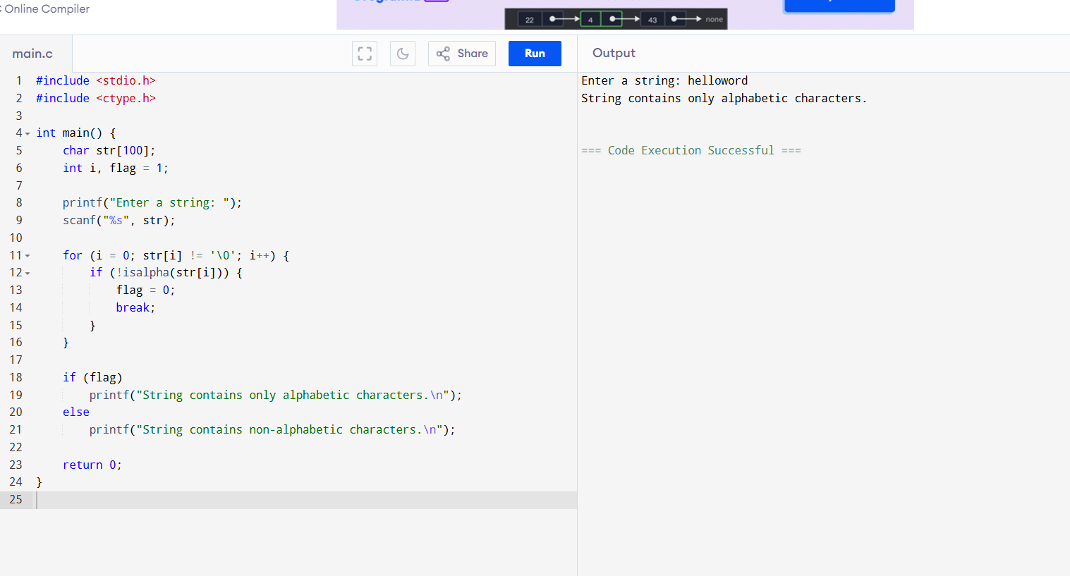

**Algorithm**

1. Start.
2. Input a string.
3. Traverse each character of the string.
4. For each character, check if it lies between 'A'–'Z' or 'a'–'z'.
5. If any character is not alphabetic, display “String contains non-alphabetic characters” and stop.
6. If all characters are alphabetic, display “String contains only alphabetic characters”.
7. Stop.

**Sample Output / Result**

**Case 1:**

1. Enter a string: Hello
2. String contains only alphabetic characters.